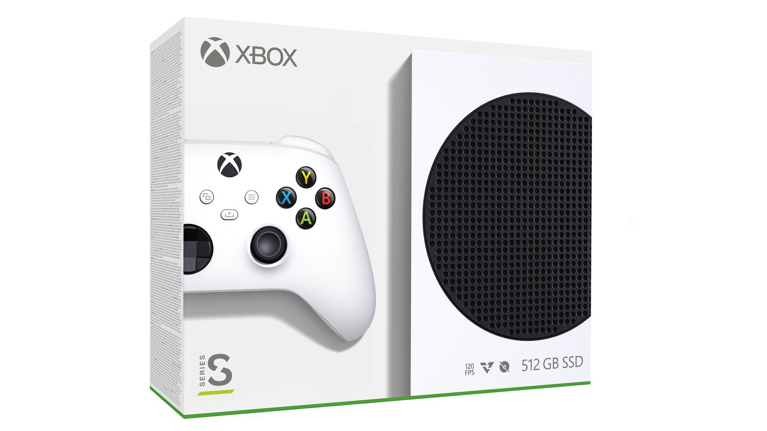

**Xbox Series S**

**Price: $299**

**Description:** The next generation of gaming brings our largest digital library yet to our smallest Xbox ever. With more dynamic worlds, faster load times, and the addition of Xbox Game Pass (sold separately), the all-digital Xbox Series S is the best value in gaming.

**System Specifications:**

* CPU: Eight-core 3.6GHz (3.4GHz with SMT) custom AMD 7nm.
* GPU: 4 teraflops at 1.550GHz.
* RAM: 10GB GDDR6.
* Storage: 512GB NV Me SSD.

**Developed By:**

